Game Name（temporary）: Limbo Maze（迷失在地狱边境）

**Background**:The prototype design of our project refers to the background of the game Limbo, where the protagonist is lost to the brink of death due to an accident, and he needs to solve numerous puzzles in order to break through the barrier of hell and return to the real world, otherwise he will be lost in the limbo forever.

**Introduction**: In Limbo Maze, players will play an explorer, explore a variety of unknown locations and solve the final puzzle to get a new lease of life.This article will introduce the design principles and elements of the game in detail, as well as the key features and highlights of the game.

Principles of game design（Based on Unity）

1. The main screen before we enter the game consists of three buttons, namely start, tutorial and exit, configure the background pattern of stars and music.

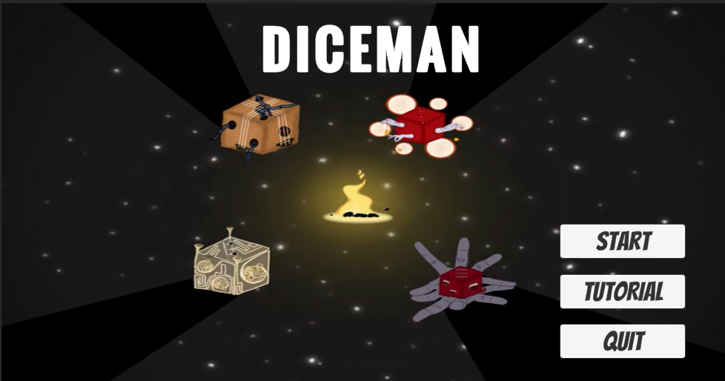

**Implementation:**

**1.**Canvas and scene insertion: In order to enhance the visual effect of the game, the game uses the canvas to insert the scene, by drawing and rendering the stars and other elements, to present the player with a realistic starry scene.After entering the game, the player will first see a hand-drawn screen, generating a 30-second video of the starry sky screen. Insert a key frame at the head and end of the video, and rotate the picture 180 degrees at the end of the key frame to form a video that rotates half a circle. The video is then copied in reverse to get a 360-degree rotation of the video footage. Then, according to the appearance order of Musical Instruments, the appearance order of characters is arranged to generate a complete video.

1. Titles and buttons: By using the Text component to insert titles, and the Button component to create a start screen and ICONS, the game visually draws the player's attention and provides an entry point for interaction.
2. Page switching: Through the custom function LoadScene, the game can realize the page switching, players click the start button, you can enter the main interface of the game.
3. Interface when player click“start”,there will be a loading animation transfer field to jump to the game's main interface.

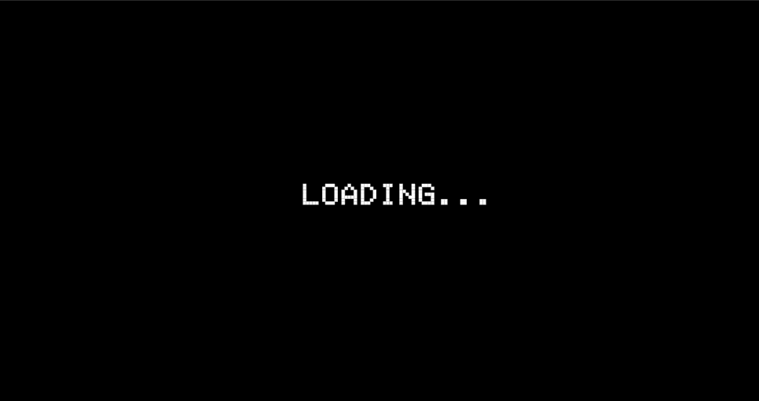

**Implementation:**

Loading interface: During scene switching, the game uses Unity's Animation component to create transition animation and uses the Animator component to store the animation scene. When the scene switches, this animation is triggered to play, providing the player with transition effects and waiting time.

1. The main interface of the game: using a first-person perspective, explore the maze and can interact with items.

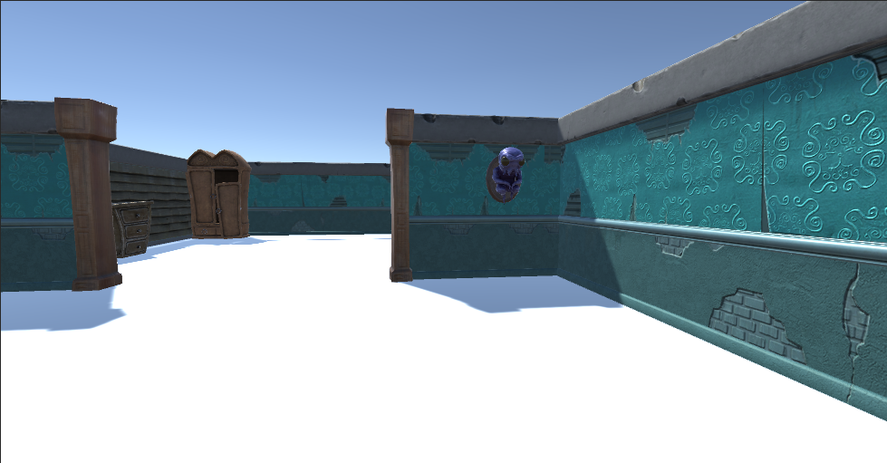

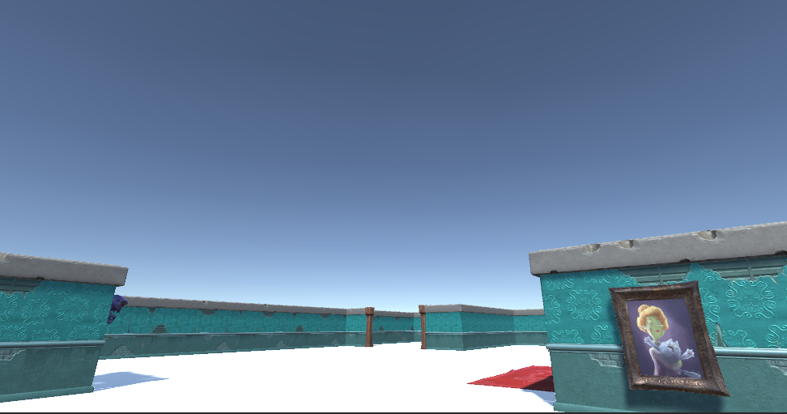

**Implementation:**

**1.**Scene construction: The scene construction in the game uses ProBuilder plug-in to build white film, and uses online materials for model placing to form a scene with a limbo sky theme. This provides the player with a realistic exploration environment.

**2.**Interactive interface: The game uses BoxCollider's Trigger trigger to trigger characters. When the player's character enters the trigger detection range, the F key can be pressed to pick up the portrait, and the V key can be pressed to drop the portrait. This interaction adds to the fun and interactivity of the game.

Game elements and features

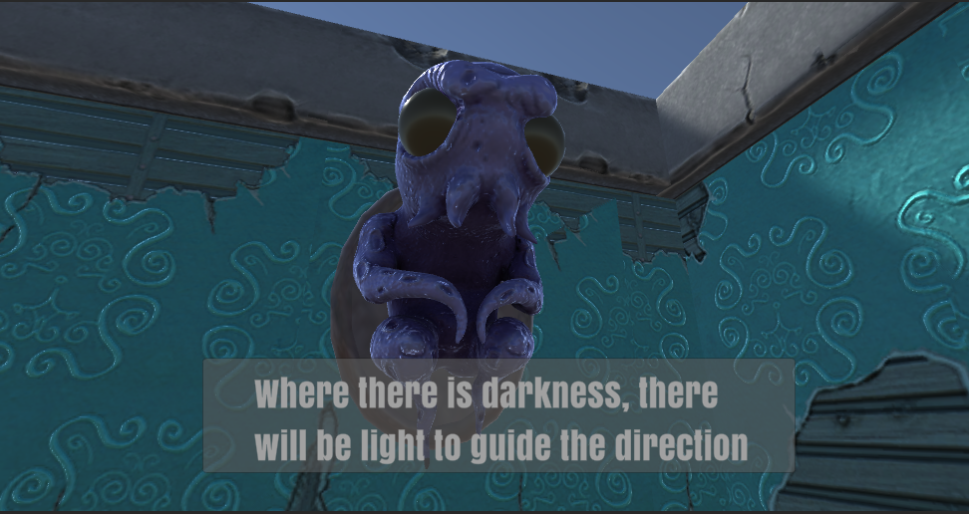

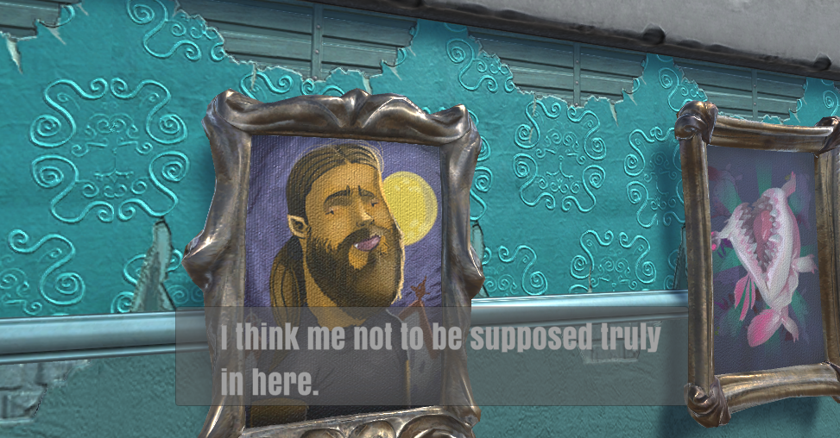

1. Backstory and setting: The game takes place in the limbo of the visual world, and the player is an explorer who reveals the secrets of the accident by exploring various unknown locations and solving puzzles.
2. Characters and items: There are items in the game, each with different abilities and characteristics, and items can be used to solve puzzles or provide help. Players need to make good use of characters and items in order to successfully complete the mission.

**3.**Sound effects and music: The sound effects and music in the game are well designed, the background music is properly selected, and the soundtrack and character movements, scene transitions and other sound effects are properly designed to provide players with an immersive game experience.

Attach:all elements of interface are drawn by hand:



